Academic Title, Author Name:
Position / Department:
Institution:
Faculty, Country:
E-mail:
ORCID:

TITLE OF THE PAPER
(Times New Roman 16, bold, upper case)

UDC / UDK: filled by Editorial staff
JEL Classification:
DOI: filled by Editorial Board
Type of paper: filled by Editorial Board
Received: filled by Editorial Board
Accepted: filled by Editorial Board

Abstract
(Times New Roman 12, bold, left aligned)

“The abstract should contain between 150 and 300 words and should briefly present the aim of the research, methodology, main findings, and conclusion of the study.
Keywords: Times New Roman, size 12. Up to 5 key words should be provided.

INTRODUCTION
(Times New Roman 12, bold, left aligned)

Normal text of the paper should be written in Times New Roman font, size 12, with justified alignment and 1.5 line spacing, in accordance with the journal formatting requirements. The Introduction should clearly define the research problem, objectives of the study, scientific relevance, and motivation for conducting the research. It is desirable that the introduction briefly outlines the structure of the paper and, where appropriate, formulates research questions or hypotheses.

- TITLE OF THE SECTION
(Times New Roman 12, bold, left aligned)

Normal text of the paper should be written in Times New Roman font, size 12, with justified alignment and 1.5 line spacing, in accordance with the journal formatting requirements. The recommended length of the manuscript is between 4,500 and 7,500 words, including references, tables, figures, appendices, and other accompanying material. The title of the paper should be written in uppercase bold letters.
  - Subtitle
(Times New Roman 12, bold, left aligned)

Subheadings should be written in lowercase bold letters and numbered according to the section structure. Normal text of the paper continues here. Normal text of the paper should be written in Times New Roman font, size 12, with justified alignment and 1.5 line spacing, in accordance with the journal formatting requirements.
    - Subtitle
(Times New Roman 12, bold, left aligned)

Additional manuscript text goes here. Headings and subheadings should be consistently formatted throughout the manuscript. Normal text of the paper should be written in Times New Roman font, size 12, with justified alignment and 1.5 line spacing, in accordance with the journal formatting requirements.
Table 1. Title of the table
Column 1 | Column 2 | Column 3 | Column 4
Data | Data | Data | Data
Data | Data | Data | Data
Data | Data | Data | Data
Data | Data | Data | Data
Source: Please provide a source website, paper, database, institutional report, or author’s own calculations (Times New Roman 10, italic, justify).

Figure 1. Title of the figure
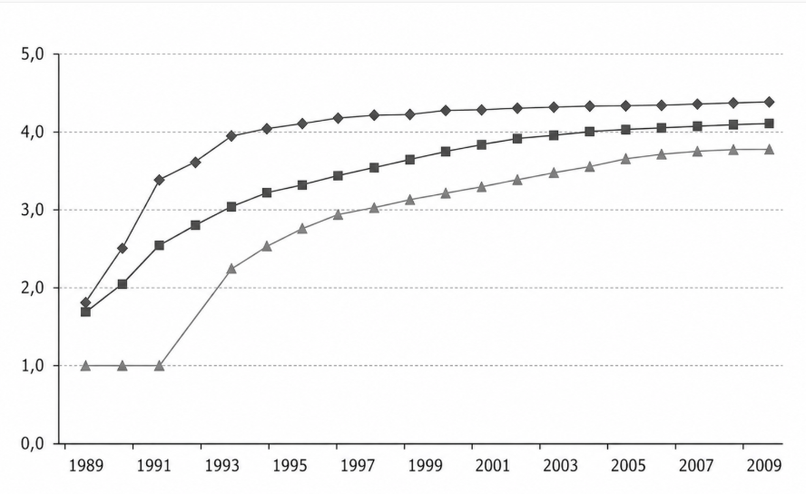
Source: Please provide a source website, paper, database, institutional report, or author’s own calculations (Times New Roman 10, italic, justify).

- RESULTS AND DISCUSSION
(Times New Roman 12, bold, left aligned)

Normal text of the paper should be written in Times New Roman font, size 12, with justified alignment and 1.5 line spacing, in accordance with the journal formatting requirements. Results and Discussion should present and critically interpret the findings of the study in relation to previous research, theoretical assumptions, and practical implications.
- CONCLUSION
(Times New Roman 12, bold, left aligned)

Normal text of the paper should be written in Times New Roman font, size 12, with justified alignment and 1.5 line spacing, in accordance with the journal formatting requirements. The Conclusion should summarize the key findings, scientific contribution, limitations of the research, and recommendations for future research. The conclusion should not merely repeat the abstract but synthesize the most important insights of the study.

Author Contributions: Conceptualization, X.X. and Y.Y.; Methodology, X.X.; Software, X.X.; Validation, X.X., Y.Y. and Z.Z.; Formal Analysis, X.X.; Investigation, X.X.; Resources, X.X.; Data Curation, X.X.; Writing – Original Draft Preparation, X.X.; Writing – Review & Editing, X.X.; Visualization, X.X.; Supervision, X.X.; Project Administration, X.X.; Funding Acquisition, Y.Y.
For single authors, use the following wording: “The author confirms sole responsibility for the following: study conception and design, data collection, analysis and interpretation of results, and manuscript preparation.”
Funding: The manuscript should contain all sources of funding for the study, clearly stated. If the research is not funded, then the following statement should be included: “The research presented in the manuscript did not receive any external funding.”
Conflict of interest: Please provide details of all known financial, professional and personal relationships with the potential to bias the work. Where no known conflicts of interest exist, please include the following statement: “None.”
Acknowledgement of AI or AI-assisted tools use: During the preparation of this paper, the author(s) used [NAME OF TOOL/SERVICE] in order to [REASON]. After using the tool/service, the author(s) reviewed and edited the content as needed and take full responsibility for the content of the published article.
Acknowledgments: If the paper is part of a doctoral dissertation, project, institutional support, or similar, acknowledgments may be included here.

REFERENCES
(Times New Roman 12, bold, left aligned)

Felix, R., Rauschnabel, P. A. & Hinsch, C. (2017). Elements of strategic social media marketing: A holistic framework. Journal of Business Research, 70(1), 118-126.
Levy, M., Weitz, B. A. & Grewal, D. (2014). Retailing Management (9th ed.). New York: McGraw-Hill Education.
Muehling, D. D. (2013). The relative influence of advertising-evoked personal and historical nostalgic thoughts on consumers' brand attitudes. Journal of Marketing Communications, 19(2), 98-113.
O'Shaughnessy, J. (2015). Competitive Marketing: A Strategic Approach. London: Routledge.
Solomon, M. R., Bamossy, G., Askegaard, S. & Hogg, M. K. (Eds.). (2006). Consumer Behaviour: A European Perspective (6th ed.). Harlow: Prentice Hall.

